Steps for Building a Project in Python – Color Detection

Here are the steps to build an application in Python that can detect colors:

1. Download and unzip the zip file

Color Detection Zip File

The project folder contains 3 files:

* **Color_detection.py** – main source code of our project.
* **Colorpic.jpg** – sample image for experimenting.
* **Colors.csv** – a file that contains our dataset.

2. Taking an image from the user

We are using argparse library to create an argument parser. We can directly give an image path from the command prompt:

import argparse

ap = argparse.ArgumentParser()

ap.add_argument('-i', '--image', required=**True**, help="Image Path")

args = vars(ap.parse_args())

img_path = args['image']

#Reading image with opencv

img = cv2.imread(img_path)

3. Next, we read the CSV file with pandas

The pandas library is very useful when we need to perform various operations on data files like CSV. **pd.read_csv()** reads the CSV file and loads it into the pandas DataFrame. We have assigned each column with a name for easy accessing.

#Reading csv file with pandas and giving names to each column

index=["color","color_name","hex","R","G","B"]

csv = pd.read_csv('colors.csv', names=index, header=None)

4. Set a mouse callback event on a window

First, we created a window in which the input image will display. Then, we set a callback function which will be called when a mouse event happens.

cv2.namedWindow('image')

cv2.setMouseCallback('image',draw_function)

With these lines, we named our window as ‘image’ and set a callback function which will call the **draw_function()** whenever a mouse event occurs.

**Want to revise the Python concepts?**

. Create the draw_function

It will calculate the rgb values of the pixel which we double click. The function parameters have the event name, (x,y) coordinates of the mouse position, etc. In the function, we check if the event is double-clicked then we calculate and set the r,g,b values along with x,y positions of the mouse.

**def** draw_function(event, x,y,flags,param):

**if** event == cv2.EVENT_LBUTTONDBLCLK:

global b,g,r,xpos,ypos, clicked

clicked = **True**

xpos = x

ypos = y

b,g,r = img[y,x]

b = int(b)

g = int(g)

r = int(r)

6. Calculate distance to get color name

We have the r,g and b values. Now, we need another function which will return us the color name from RGB values. To get the color name, we calculate a distance(d) which tells us how close we are to color and choose the one having minimum distance.

Our distance is calculated by this formula:

*d = abs(Red – ithRedColor) + (Green – ithGreenColor) + (Blue – ithBlueColor)*

**def** getColorName(R,G,B):

minimum = 10000

**for** i **in** range(len(csv)):

d = abs(R- int(csv.loc[i,"R"])) + abs(G- int(csv.loc[i,"G"]))+ abs(B- int(csv.loc[i,"B"]))

**if**(d<=minimum):

minimum = d

cname = csv.loc[i,"color_name"]

**return** cname

7. Display image on the window

Whenever a double click event occurs, it will update the color name and RGB values on the window.

Using the **cv2.imshow()** function, we draw the image on the window. When the user double clicks the window, we draw a rectangle and get the color name to draw text on the window using **cv2.rectangle** and **cv2.putText()** functions.

**while**(1):

cv2.imshow("image",img)

**if** (clicked):

#cv2.rectangle(image, startpoint, endpoint, color, thickness) -1 thickness fills rectangle entirely

cv2.rectangle(img,(20,20), (750,60), (b,g,r), -1)

#Creating text string to display ( Color name and RGB values )

text = getColorName(r,g,b) + ' R='+ str(r) + ' G='+ str(g) + ' B='+ str(b)

#cv2.putText(img,text,start,font(0-7), fontScale, color, thickness, lineType, (optional bottomLeft bool) )

cv2.putText(img, text,(50,50),2,0.8,(255,255,255),2,cv2.LINE_AA)

#For very light colours we will display text in black colour

**if**(r+g+b>=600):

cv2.putText(img, text,(50,50),2,0.8,(0,0,0),2,cv2.LINE_AA)

clicked=**False**

#Break the loop when user hits 'esc' key

**if** cv2.waitKey(20) & 0xFF ==27:

break

cv2.destroyAllWindows()

8. Run Python File

The beginner Python project is now complete, you can run the Python file from the command prompt. Make sure to give an image path using ‘-i’ argument. If the image is in another directory, then you need to give full path of the image:

python color_detection.py -i <add your image path here>

[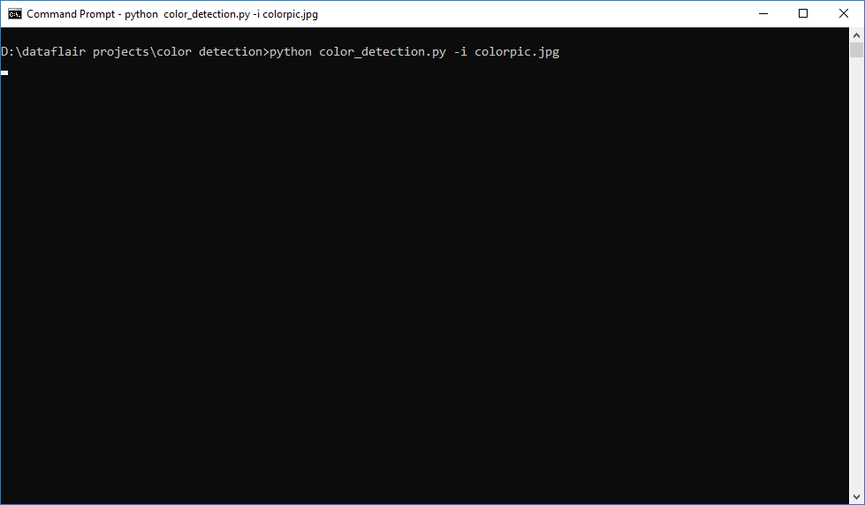](https://data-flair.training/blogs/wp-content/uploads/sites/2/2019/12/running-python-project.png)

**Screenshots:**

[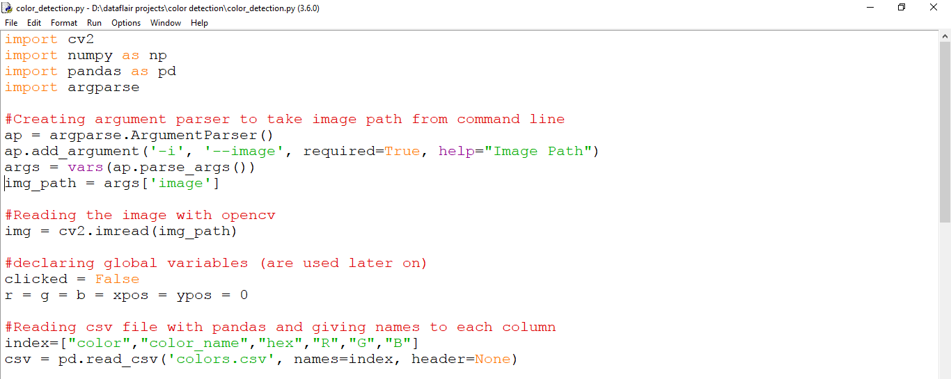](https://data-flair.training/blogs/wp-content/uploads/sites/2/2019/12/import-cv2.png)

[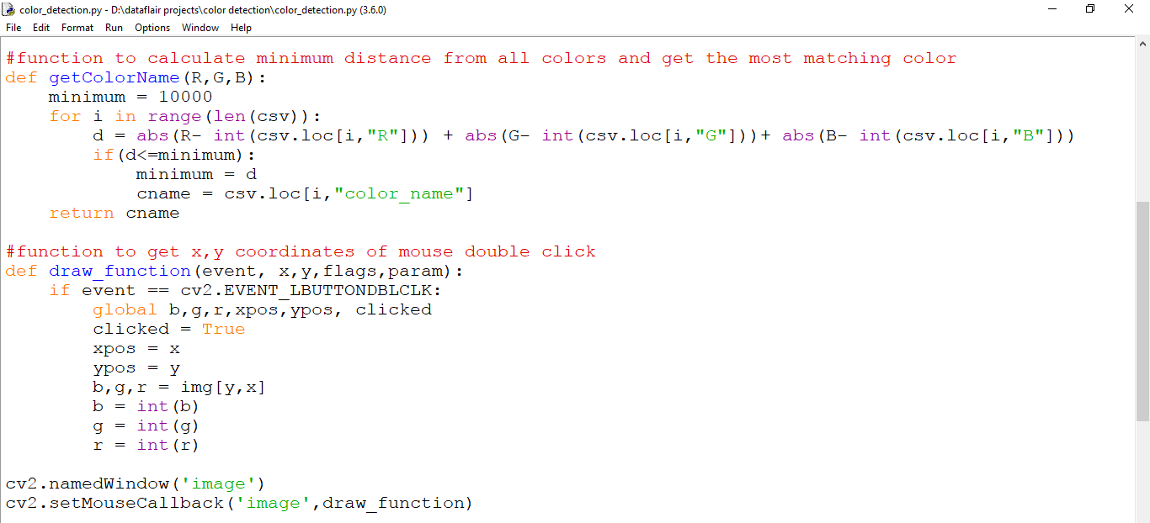](https://data-flair.training/blogs/wp-content/uploads/sites/2/2019/12/def-getColorName-project-in-python.png)

[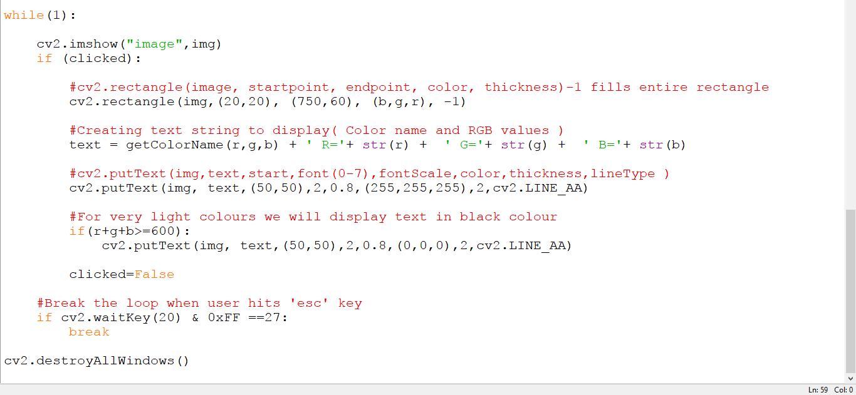](https://data-flair.training/blogs/wp-content/uploads/sites/2/2019/12/while-1-python-data-science-project.png)

**Output:**

Double click on the window to know the name of the pixel color

[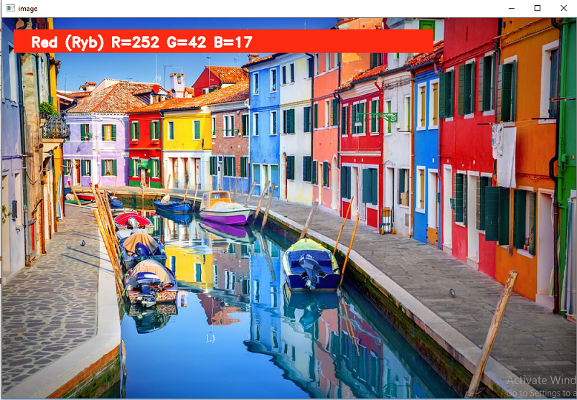](https://data-flair.training/blogs/wp-content/uploads/sites/2/2019/12/red-color-detection-python-mini-project.png)

[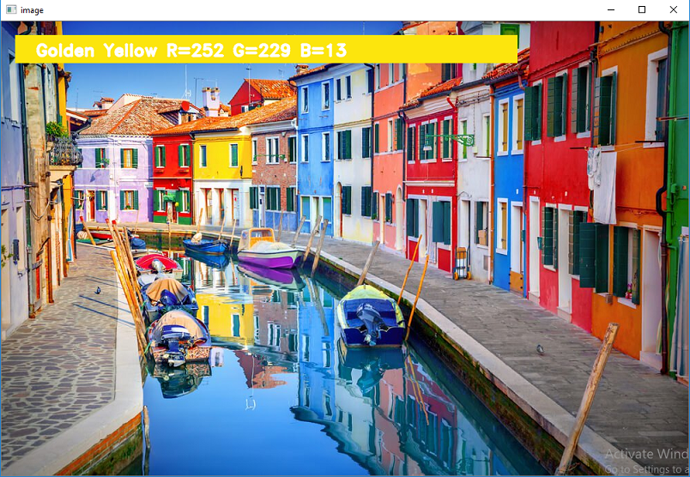](https://data-flair.training/blogs/wp-content/uploads/sites/2/2019/12/yellow-color-detection-python-project-with-source-code.png)

[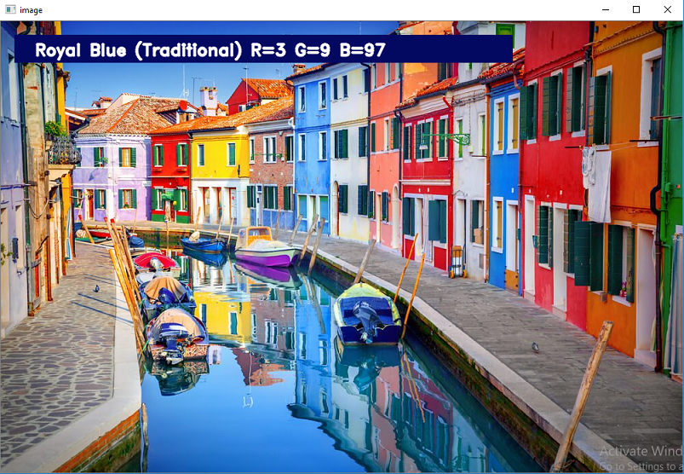](https://data-flair.training/blogs/wp-content/uploads/sites/2/2019/12/blue-color-detection-python-project.png)

Summary

In this Python project with source code, we learned about colors and how we can extract color RGB values and the color name of a pixel. We learned how to handle events like double-clicking on the window and saw how to read CSV files with pandas and perform operations on data. This is used in numerous image editing and drawing apps.